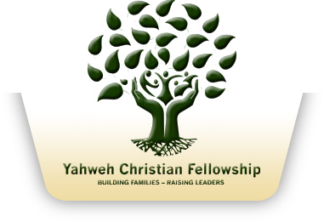
Yahweh Christian Fellowship
Livestream Production Schedule
Date: 23.08.2020

Start time | Duration | End Time | Item | person
10:50AM | 10mins | 11:00AM | Livestream countdown video | Livestream operator (name)
11:00AM | 3 mins | 11:03AM | Intro and prayer | Bishop Noel / Pastor Sharon
11:03AM | 15mins 43s | 11:19AM | Worship (pre-recorded Video file) | Livestream operator (name)
11:19AM | 10 mins | 11:29AM | Announcements, prayer and or guest testimony | Pastor Sharon
11:29AM | 45min | 12:14PM | Word | Bishop Noel
12:14PM | 10mins | 12:24 | Close by pastor Sharon | Pastor Sharon
End

